Front-end Use case diagram for GRST project

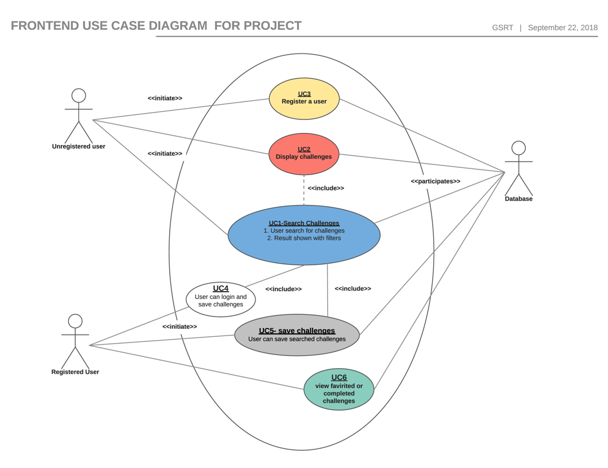

Backend Use case diagram for GRST Project

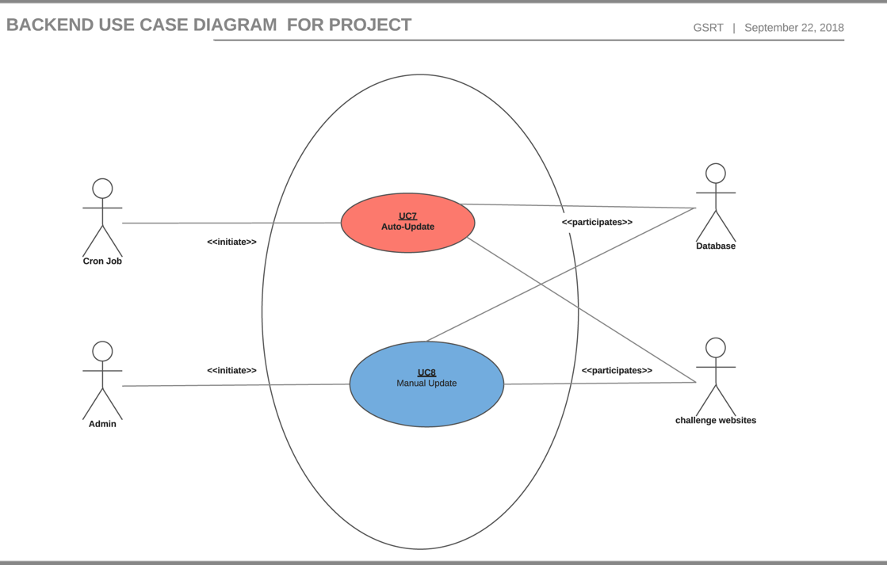

Sequence diagram for Use case 1.

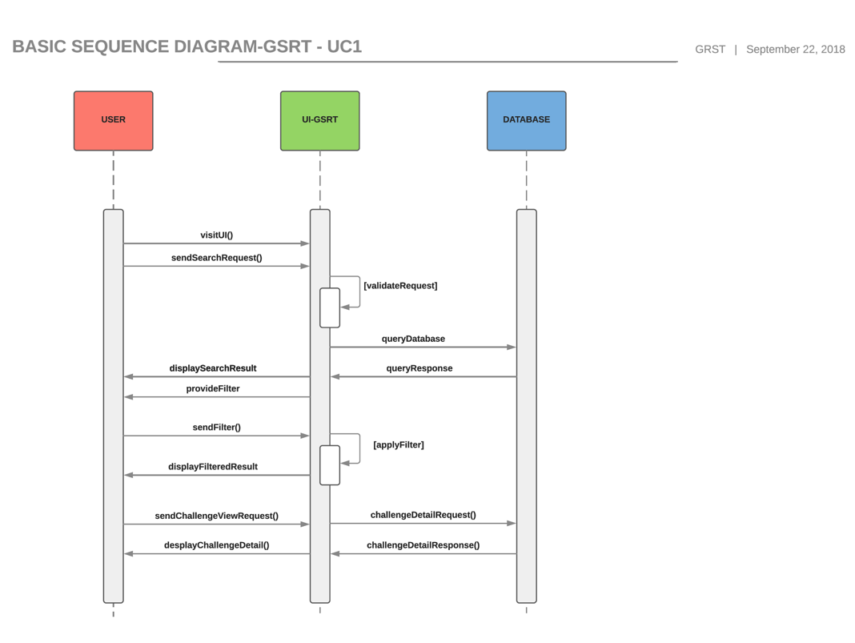

Sequence diagram for Use case 1 & UC2.

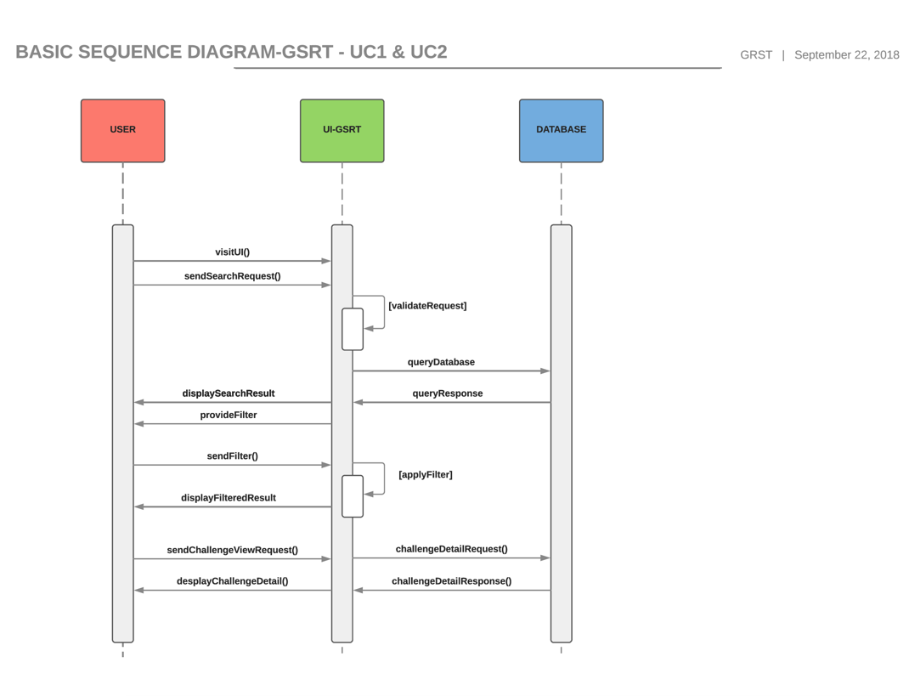

Sequence diagram for Use case 3.

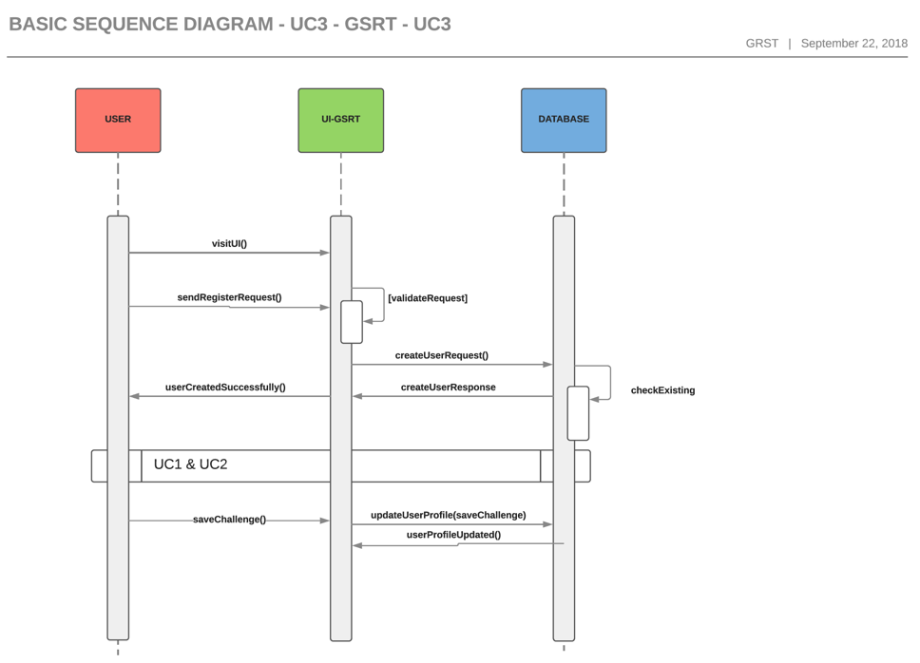

Sequence diagram for Use case 4, 5 & 6.

